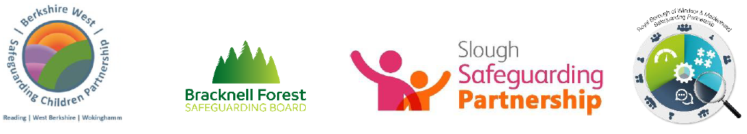
Pan Berkshire Child Exploitation
Simple Screening Tool
Guidance on completing the tool

The screening tool uses the term ‘child’ deliberately to remind us that a child at risk through exploitation is a child in need of protection and not a young adult making poor choices. It is designed to be used by anyone who has concerns for a child. A child is defined as person who is under 18 years of age.

The screening tool is designed to help identify possible risks of exploitation and/or serious youth violence. Your observations of behaviours and any significant changes will be important as children will often deny or be unaware that they are being exploited.

Significant changes in behaviours, a single high-risk episode or multiple risk factors may indicate that the child is a victim of abuse through exploitation rather than a teenager experimenting with risk taking.

Sexual Exploitation | any sexual activity with a child in exchange or to either enhance perpetrators reputation/status or for the financial gain of the perpetrator
Criminal Exploitation | Forcing/coercing a child to engage in criminal behaviour e.g.: drug dealing, county lines, holding weapons/drugs, ABH, GBH, shoplifting, burglary, mugging (robbery) etc.…
Forced Labour | Employing a child to undertake some form of employment to pay off any ‘debts’ or pay them minimal amounts. Engage in work that is illegal for their age. This can also include domestic servitude.
Serious Youth Violence

Often, children do not recognise themselves as victims, or that they are being groomed, and as a result disclosures of such abuse can be unlikely. Therefore, this indicator tool aids the identification of exploitation.

This is an initial screening tool, and not a risk assessment. Please complete as fully as possible. If there are indicators of Exploitation, please contact:

Children’s Single Point of Access (Reading)

www.reading.gov.uk/childrensreferralform Call: 0118 937 3641 (Mon – Fri 9am to 5pm)

The list of questions and observations within this screening tool is not exhaustive. Therefore, regardless of the lack of identified indicators, if you are still concerned about exploitation, please contact Children’s Single Point of Access.

Child’s Name

Date of Birth

Gender
Home or placement address
What is your relationship to the child?
Name and contact phone number of person completing the screening tool
School attended by child

Risk Indicators  Children are groomed and exploited in different ways. Below are some signs that may signify if the child is being groomed for exploitation, or actually being exploited. | Observations / Detail
Child located in areas known for on/off street sex work and/or drug supply
Disclosure of sexual/physical assault, possibly followed by withdrawal of allegation.

Entering/leaving vehicles driven by unknown adults.

Knowledge of/connection to town or cities child has no previous connection with.

Identified links with taxi firms/takeaway owners/night-time economy.

Evidence of unexplained / suspicious public transport - rail / bus tickets to places where they have no trusted association
Possession of a knife / self-defence weapon

Seen in hotspots/places of concern

Change in behaviour – being more secretive/ withdrawn/ isolated from peers and not mixing with usual friends.

Increasingly disruptive, hostile or physically aggressive at home or school, including to animals, and the use of sexualised language.

Older person(s) contacting the child online/offline, and encouraging emotional dependence, loyalty and isolation.

Physical/emotional abuse from a partner, controlling adult or peer, including use of manipulation, violence and/or threats.

Possession of keys to unknown premises and/or hotel key cards.

Victim of a violent offence or threatened with violence/physical assault

Phone calls, texts, letters from unknown adults.

Persistently missing from home/care/school for different periods including overnight, including episodes that aren’t reported to Police.

Returning home after long intervals appearing well cared for or dirty/dishevelled.

Change in physical appearance (more/new clothes, more/less make up, weight gain/loss).

Unexplained marks/scars/physical injuries and attempts to conceal them.

Attendance at a hospital / surgery with a stab wound

Expression of despair (depression, mental health, self-harm, suicidal thoughts/attempts, eating disorder).

Repeat/unplanned pregnancy(s) and/or seeking termination/emergency contraception.

Sexually transmitted infections (STI’s) and/or repeat visits to the sexual health clinic.

Adults/unexplained person(s) loitering outside the child/young person’s usual place of residence or school.

Concealed/concerning use of the internet and/or mobile phone, including during the night (webcam, online gaming, web chat, social media, online dating apps/websites).

Concern that an online relationship has developed into an offline relationship.

Involvement in offending.

Peers / siblings involvement in violent offending / weapon carrying / drug offences

Exclusion from school, disengaged from education, unexplained absences from school.

No response to attempts from workers/carers to keep in touch/disengagement from professionals.

Evidence of older, or unknown persons sending sexualized messages to the child.

Young persons sexuality being explored in a risky or unsupported way.

Association with groups/gangs/fear of victimisation from groups/gangs.

Increasing use of drugs/alcohol or misuse of drugs/alcohol.

Concern that the child/young person is being coerced/bribed/threatened to provide sexually explicit images/engage in inappropriate online activity.

Unexplained money/clothing/goods/activities.

Possessing multiple mobile phones, sim cards, or concerning use of a phone, i.e. multiple callers, frequent messages, phone answered by adult/unknown person.

Becoming angry/hostile if any suspicions or concerns are expressed about their activities

Date Tool Completed………………………………………………..

If the child has made a disclosure of being exploited or abused, you must contact the police immediately.

